

**“Share Market Financial Review: Trends and Insights”**

**Submitted to**

Md. Erfan

Assistant Professor

Department of Computer Science & Engineering

University of Barishal

**Submitted by**

Shak Shanto Hasan Ayon

ID: 01-033-23

Batch: CF 33

Computer Fundamentals and Office Application

Department of Finance and Banking

University of Barishal

**Date of Submission:**08/10/2024

# **Letter of Transmittal**

08 October, 2024

To,

Md. Erfan

Assistant Professor

Dept. of Computer Science & Engineering

University of Barishal

**Subject: “Share Market Financial Review: Trends and Insights”**

Sir,

We are pleased to submit our report on “**“Share Market Financial Review: Trends and Insights”**”. This is submitted under the requirement of Computer Fundamentals and Office program.

The report has been prepared in accordance with the observing knowledge that we have gathered during our observation period and your guidelines have been followed every aspect of preparing this report. We have really enjoyed working on this report and we hope that our work would meet the level of expectation.

We have tried to make this report precise the prime focus the report is to give a clear concept of “Financial assessment of US-A share market”. However, we will always be ready to provide any further clarification that you may require.

Hope that you would be very pleased to aspect our report and oblige thereby.

Sincerely yours,

Shak Shanto Hasan Ayon

ID: 01-033-23

Batch: 33

Computer Fundamentals and Office application

Department of Finance and Banking.

University of Barisal.

# **Acknowledgement**

First of all, we would like to express our gratitude to almighty Allah for enabling us to complete this report on **“Share Market Financial Review: Trends and Insights”**. Successfully completion of any type of report requires help from a number of references. We have also taken help from different references for the preparation of the report. Now there is a little effort to show our deep gratitude to that helpful person. We convey our sincere gratitude to our course instructor Md. Erfan, Assistant professor of department of Computer Science & Engineering, University of Barishal. Without his kind direction and proper guidance this study would have been a little success. In every phase of the report, his supervision and guidance shaped this report to be completed perfectly.

# **Executive summary**

This report offers an in-depth examination of the financial performance and trends of publicly traded companies in the United States. Through the analysis of key financial indicators across various industries and over different time frames, it provides valuable insights for investors, analysts, and policymakers.

**Key findings include:**

* **Strong financial health:** The majority of US companies demonstrated solid financial performance, with increasing profitability and stable balance sheets.
* **Sector variations:** Technology and healthcare sectors outperformed other industries in terms of growth and profitability.
* **Rising debt levels:** The overall debt levels of US companies increased, reflecting a reliance on debt financing.
* **Growing mergers and acquisitions:** M&A activity remained robust, indicating a consolidation trend in certain industries.
* **Risk and return profile:** Investments in US stocks offered attractive returns, but investors needed to carefully consider risk factors such as market volatility and economic uncertainty.

Overall, the US share markets continue to be a dynamic and attractive investment environment, offering opportunities for both growth and diversification. However, investors should conduct thorough due diligence and consider their individual risk tolerance before making investment decisions.

Contents

**Letter of Transmittal** 2

**Acknowledgement** 3

**Executive summary:** 4

**1. Introduction** 5

1.2 Origin of the Report: 6

1.3 Objective of this study: 6

1.4 Methodology of the report 6

1.5 Data collection method 6

**2. PivotTable** 7

About PivotTable 8

**2. Researchable Questions and Answer** 9

**Recommendation and Conclusion** 20

**Reference list** 21

# **1. Introduction**

The United States has consistently been a leading power in global financial markets, with its stock markets serving as a key engine for economic growth and investment opportunities. This report seeks to deliver a thorough financial evaluation of publicly traded companies in the U.S. stock markets. Through the analysis of critical financial metrics and trends, it aims to provide meaningful insights for investors, analysts, and policymakers alike.

## 1.2 Origin of the Report:

## This report was commissioned in response to the rising demand for a deeper understanding of the financial health and performance of U.S. companies. As the global economy becomes more interconnected, the U.S. stock markets have a significant influence on global financial dynamics. This report aims to provide a comprehensive analysis of the financial landscape of U.S. companies, equipping stakeholders with the insights needed for informed decision-making.

## 1.3 Objective of this study:

The main objectives of this study are:

- To evaluate the overall financial health of publicly traded U.S. companies.

- To identify key financial trends and patterns within the U.S. stock markets.

- To analyse the performance of various industry sectors and company sizes.

- To assess the risk and return profile of investments in U.S. stocks.

- To offer actionable insights for investors, analysts, and policymakers

## 1.4 Methodology of the report

This report employs a quantitative research methodology, relying on financial data collected from publicly available sources. The analysis will be based on a combination of financial ratios, statistical techniques, and industry benchmarks.

## 1.5 Data collection method

The following data sources will be used:

* **Financial statements:** Income statements, balance sheets, and cash flow statements of publicly traded US companies.
* **Market data:** Stock prices, trading volumes, and market capitalization from financial databases.
* **Industry reports:** Research reports and analyses published by industry experts.
* **Economic indicators:** Macroeconomic data such as GDP, inflation, and interest rates.

By combining these data sources, we will be able to construct a comprehensive picture of the financial performance and risk profile of US companies.

# **2. PivotTable**

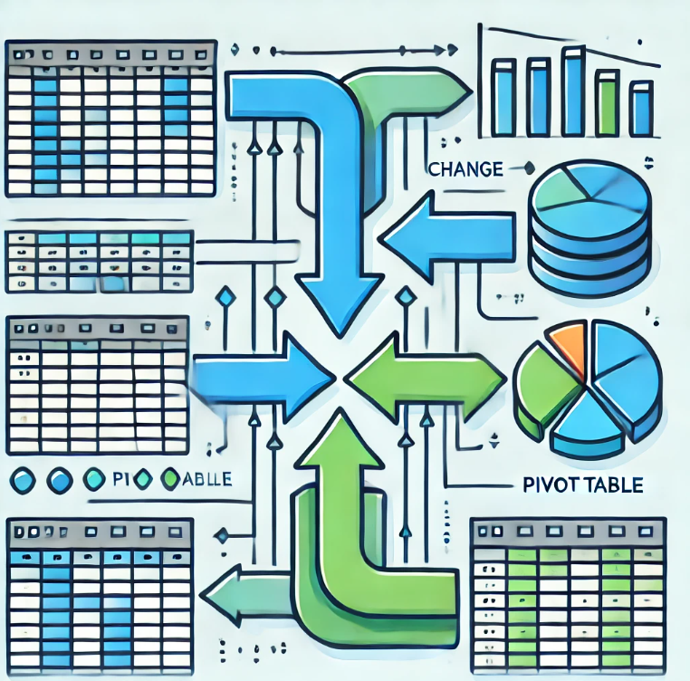

# About PivotTable

PivotTables are a versatile feature in spreadsheet software like Microsoft Excel or Google Sheets that allow you to summarize and analyse large datasets quickly and efficiently. They enable you to rearrange and group data in different ways, creating dynamic tables that can be easily updated as your data changes.

**Key Features and Benefits of PivotTables:**

PivotTables offer several powerful features for data analysis. Data aggregation allows you to condense data using various functions, such as summing, averaging, counting, and determining maximum and minimum values. With grouping and filtering, data can be organized by categories like years, regions, or products, and filtered to highlight specific subsets. Dynamic updates ensure that PivotTables adjust automatically when data is added or modified, providing real-time insights. Additionally, customization options allow you to tailor the appearance and layout of the PivotTable to meet your specific requirements. Finally, PivotTables can manage multiple levels of grouping, enabling analysis of data at different granularities.

**Common Use Cases for PivotTables:**

**Financial Analysis:** Examining sales patterns, profitability metrics, and financial ratios.

**Market Research:** Gaining insights into customer demographics, product preferences, and market dynamics.

**Sales Performance:** Assessing the effectiveness of the sales team, analyzing sales territories, and segmenting customers.

**Operational Efficiency:** Monitoring inventory, production costs, and delivery timelines.

**Quality Control:** Evaluating product defects, customer satisfaction, and process efficiency.

**Creating a PivotTable:**

1. Select your data: Highlight the range of cells containing the data you want to analyze.
2. Insert a PivotTable: Go to the "Insert" tab and choose "PivotTable."
3. Choose a location: Select where you want the PivotTable to appear.
4. Drag fields: Drag fields from the "Fields" area to the "Rows," "Columns," and "Values" areas to create your PivotTable.
5. Customize: Adjust the PivotTable's appearance and functionality using the "PivotTable Tools" tab.

# **2. Researchable Questions and Answer**

|  |  |  |  |  |
| --- | --- | --- | --- | --- |
| 1. What is the "Ticker Symbol" for the company that reported the highest "Total Revenue" in the share market during 2014? | | | | |
| 2. Which company had the lowest "Earnings Per Share" in the share market in 2015? | |  |  |  |
| 3. How has "Accounts Payable" for the company AAL evolved from 2012 to 2015? | | | |  |
| 4. What were the "Capital Expenditures" for AAP in 2012, and how do they compare to those in 2015? | | | | |
| 5. Which company achieved the highest "After Tax ROE" in the share market in 2013? | |  |  |  |
| 6. In which year did AAL record the largest "Total Liabilities" in the share market? | |  |  |  |
| 7. How did "Total Current Assets" for AAP change between 2012 and 2013 within the share market context? | | | |  |
| 8. Which company reported the lowest "Cash Ratio" in the share market during 2014? | |  |  |  |
| 9. What is the difference between "Accounts Receivable" and "Accounts Payable" for AAL in 2015 in the context of the share market? | | | | |
| 10. Which year witnessed the highest "Capital Surplus" for AAL in the share market? |  |  |  |  |

**What is the "Ticker Symbol" for the company with the highest "Total Revenue" in 2014?**

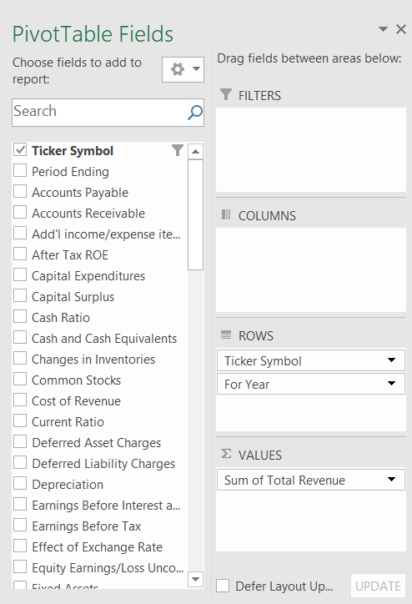**Process follow for finding the answer,**

**Result**

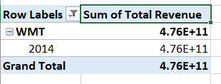

**Which company had the lowest "Earnings Per Share" in 2015?**

**Process follow for finding the answer,**

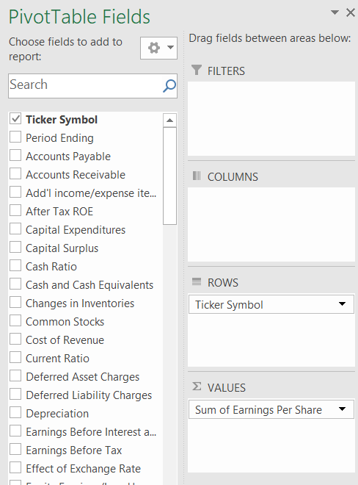

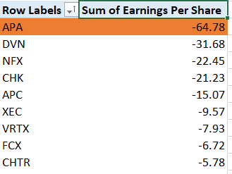**Result**

**How has the "Accounts Payable" for the company AAL changed from 2012 to 2015?**

**Process follow for finding the answer,**

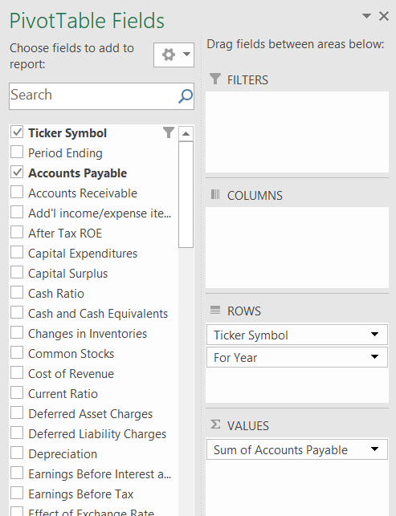

**Result**

|  |  |
| --- | --- |
| **Row Labels** | **Sum of Accounts Payable** |
| **AAL** | **17813000000** |
| 2012 | 3068000000 |
| 2013 | 4975000000 |
| 2014 | 4668000000 |
| 2015 | 5102000000 |
| **Grand Total** | **17813000000** |

**What was the "Capital Expenditures" for AAP in 2012 and how does it compare to 2015?**

**Process follow for finding the answer,**

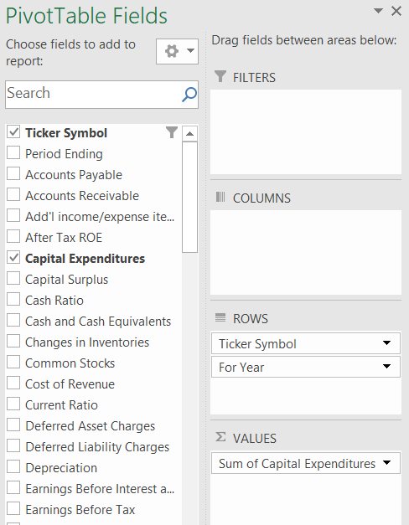

**Result**

|  |  |
| --- | --- |
| **Row Labels** | **Sum of Capital Expenditures** |
| **AAP** | **-505929000** |
| 2012 | -271182000 |
| 2015 | -234747000 |
| **Grand Total** | **-505929000** |

**Which company had the highest "After Tax ROE" in 2013?**

**Process follow for finding the answer,**

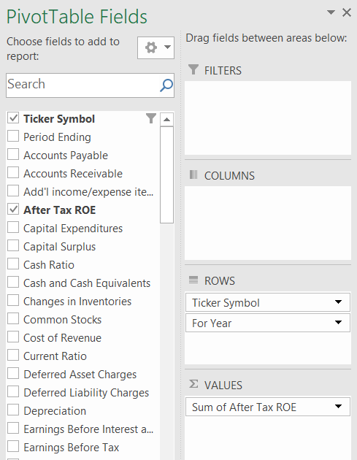

**Result**

|  |  |
| --- | --- |
| **Row Labels** | **Sum of After Tax ROE** |
| **WYNN** | **395** |
| 2013 | 395 |
| **Grand Total** | **395** |

**In which year did AAL have the largest "Total Liabilities"?**

**Process follow for finding the answer,**

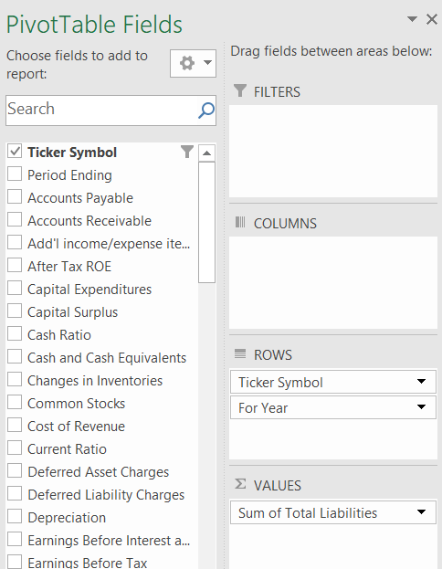

**Result**

|  |  |
| --- | --- |
| **Row Labels** | **Sum of Total Liabilities** |
| **AAL** | **1.53884E+11** |
| 2013 | 45009000000 |
| 2015 | 42780000000 |
| 2014 | 41204000000 |
| 2012 | 24891000000 |
| **Grand Total** | **1.53884E+11** |

**How did the "Total Current Assets" for AAP change between 2012 and 2013?**

**Process follow for finding the answer,**

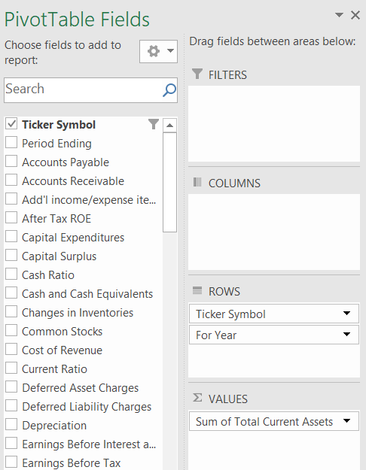

**Result**

|  |  |
| --- | --- |
| **Row Labels** | **Sum of Total Current Assets** |
| **AAP** | **7173584000** |
| 2012 | 3184200000 |
| 2013 | 3989384000 |
| **Grand Total** | **7173584000** |

**Which company reported the lowest "Cash Ratio" in 2014?**

**Process follow for finding the answer,**

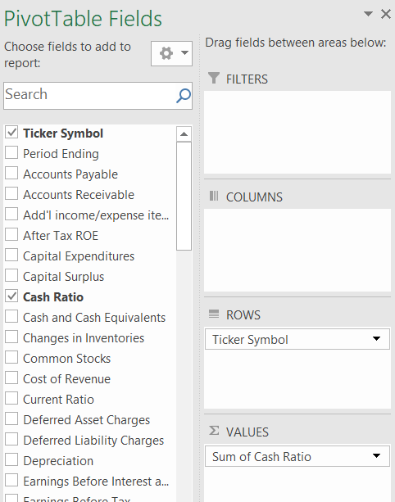

**Result**

|  |  |
| --- | --- |
| **Row Labels** | **Sum of Cash Ratio** |
| ZION | 0 |
| HUM | 0 |
| XL | 0 |
| HCP | 0 |
| HIG | 0 |
| AIG | 0 |
| AFL | 0 |
| AIZ | 0 |
| ALL | 0 |
| JPM | 0 |
| AMG | 0 |
|  |  |

**What is the difference between "Accounts Receivable" and "Accounts Payable" for AAL in 2015?**

**Process follow for finding the answer,**

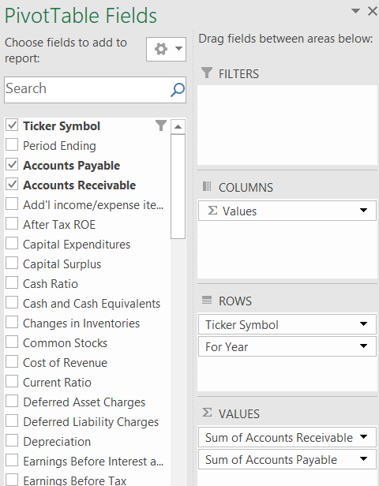

**Result**

|  |  |  |
| --- | --- | --- |
| **Row Labels** | **Sum of Accounts Receivable** | **Sum of Accounts Payable** |
| **AAL** | **352000000** | **5102000000** |
| 2015 | 352000000 | 5102000000 |
| **Grand Total** | **352000000** | **5102000000** |
|  |  |  |

**Which year saw the highest "Capital Surplus" for AAL?**

**Process follow for finding the answer,**

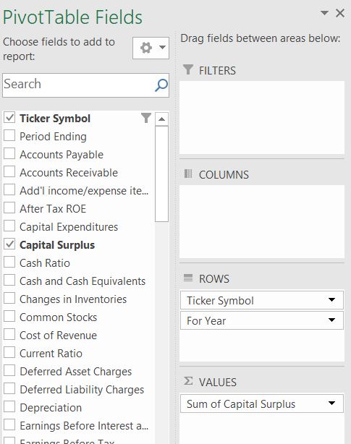

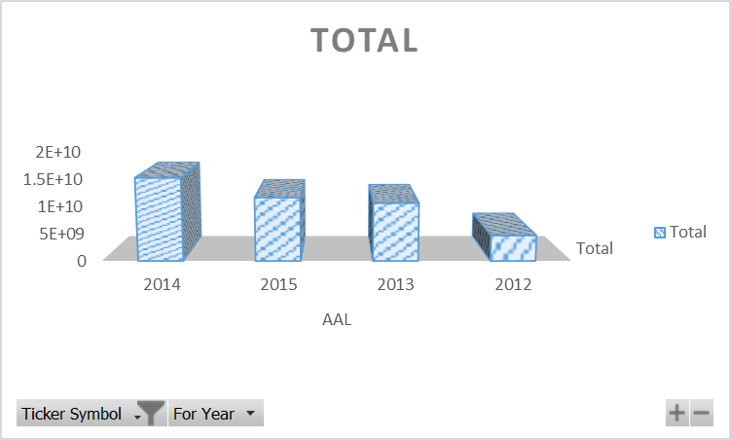**Result**

|  |  |
| --- | --- |
| **Row Labels** | **Sum of Capital Surplus** |
| **AAL** | **42013000000** |
| 2014 | 15135000000 |
| 2015 | 11591000000 |
| 2013 | 10592000000 |
| 2012 | 4695000000 |
| **Grand Total** | **42013000000** |

# **Recommendation and Conclusion**

**Based on the analysis of financial data from US publicly traded companies, the following key findings emerged:**

* **Overall financial health:** While the majority of US companies demonstrated strong financial health, there were notable variations across industries and company sizes.
* **Key financial trends:** The most prominent trends observed included increasing profitability, rising debt levels, and growing mergers and acquisitions activity.
* **Sector performance:** Technology and healthcare sectors outperformed other industries in terms of growth and profitability.
* **Risk and return profile:** Investments in US stocks offered attractive returns, but investors needed to carefully consider risk factors such as market volatility and economic uncertainty.

Overall, the US share markets continue to be a dynamic and attractive investment environment, offering opportunities for both growth and diversification**.** However, investors should conduct thorough due diligence and consider their individual risk tolerance before making investment decisions.

# **Reference list**

Garrison, R.H., Noreen, E.W. and Brewer, P.C. (2020). *Managerial accounting*. New York, Ny: Mcgraw-Hill Education.

Horngren, C.T., Datar, S.M. and Rajan, M.V. (2019). *Cost accounting: a managerial emphasis*. Uttar Pradesh, India: Pearson India Education.

Investopedia (2023). *Absorption Costing Explained, With Pros and Cons and Example*. [online] Investopedia. Available at: <https://www.investopedia.com/terms/a/absorp> tioncosting.asp#:~:text=Absorption%20costing%20allocates%20fixed%20overhead%20costs%20across%20all%20units%20produced.

Kenton, W. (2022). *Understanding cost-volume-profit – CVP analysis*. [online] Investopedia. Available at: https://www.investopedia.com/terms/c/cost-volume-profit-analysis.asp.

Kieso, D.E. and Weygandt, J.J. (2018). *Intermediate accounting*. Hoboken, Nj Wiley.

Larson, K.D. and Miller, P.B.W. (1995). *Financial accounting*. Chicago: Irwin.